Graded Project on Orchestration and Scaling assignment – Feb16,2026
## System architecture

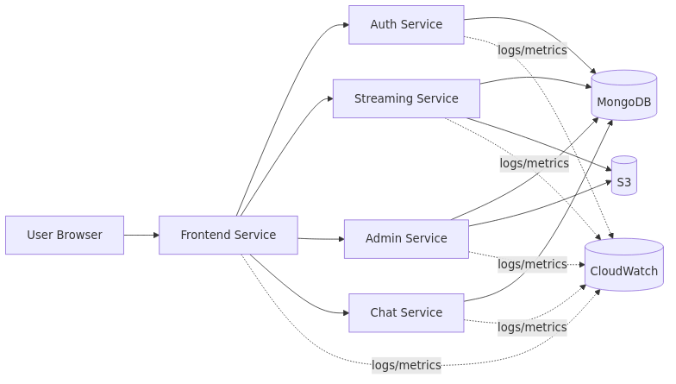

Step 1 — Version control with Git

## Project repository
- Main repository (upstream): `https://github.com/UnpredictablePrashant/StreamingApp.git`
Forked repo
https://github.com/manjulachukki/StreamingApp.git
### 1.2 Clone your fork and add upstream remote

```bash
git clone https://github.com/<your-username>/StreamingApp.git
cd StreamingApp

git remote add upstream https://github.com/UnpredictablePrashant/StreamingApp.git
git remote -v
```

### 1.3 Sync your fork with upstream

```bash
git fetch upstream
git checkout main

git merge upstream/main
# or: git rebase upstream/main

git push origin main

Step 2 — Prepare the MERN application (Docker)
2.1 Containerize the Application
This repo includes Dockerfiles under:

- `backend/authService/Dockerfile`
- `backend/streamingService/Dockerfile`
- `backend/adminService/Dockerfile`
- `backend/chatService/Dockerfile`
- `frontend/Dockerfile`
`docker-compose.yml` builds and runs all services together.
2.2 Push Docker images to Amazon ECR
We tag images directly for ECR using `image:` entries in `docker-compose.yml`:

- `streamingapp-auth`
- `streamingapp-streaming`
- `streamingapp-admin`
- `streamingapp-chat`
- `streamingapp-frontend`

Picture 1: Create/verify ECR repositories (or list repos)
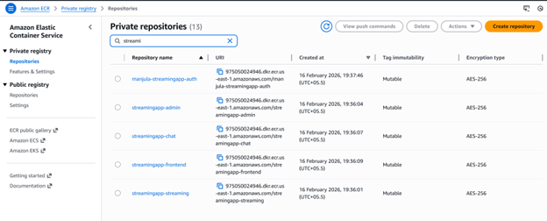
Picture 3: Push the images to their respective ECR repositories.

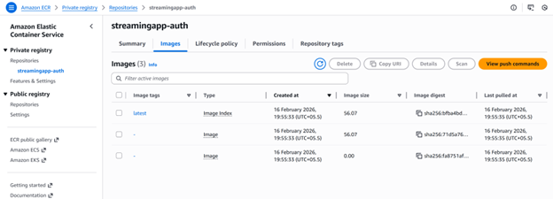
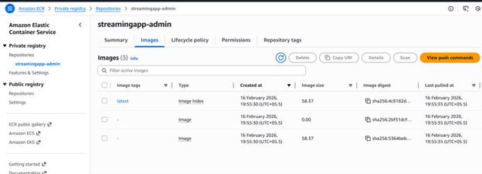
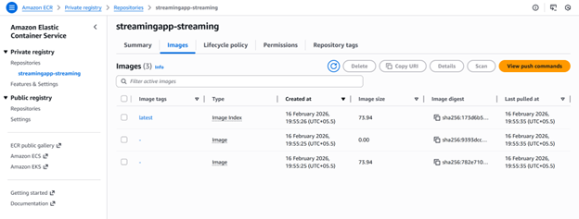
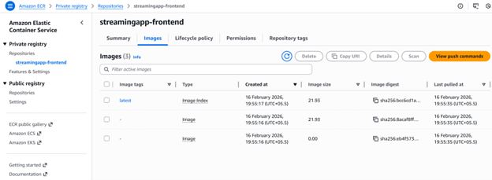
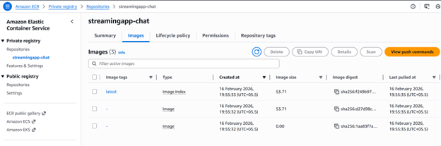

Step 3 — AWS environment setup (CLI)
Configure AWS CLI and verify identity
Verify credentials:
```bash
aws sts get-caller-identity```

Set default region:
```bash
aws configure set region ap-south-1

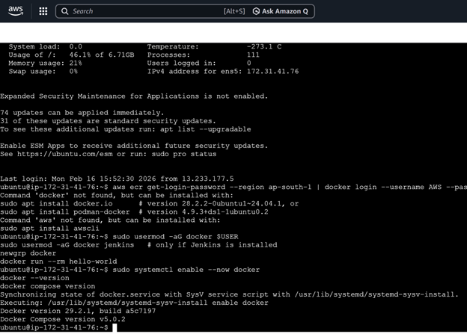
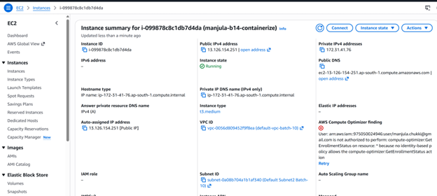

Step 4 — Continuous Integration (CI) using Jenkins
Jenkins agent runs on an EC2 with an IAM role that can push to ECR.
Picture 7: Jenkins pipeline/job configuration

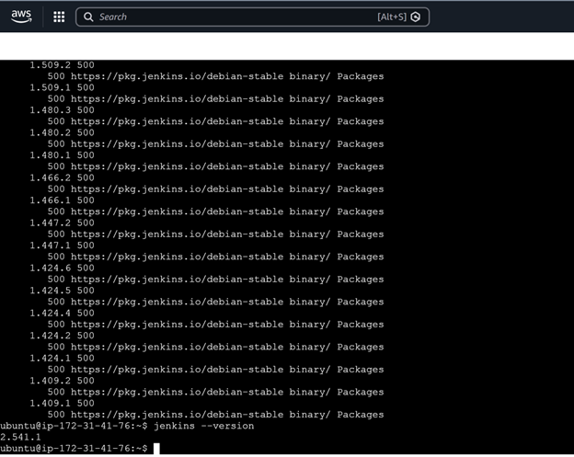
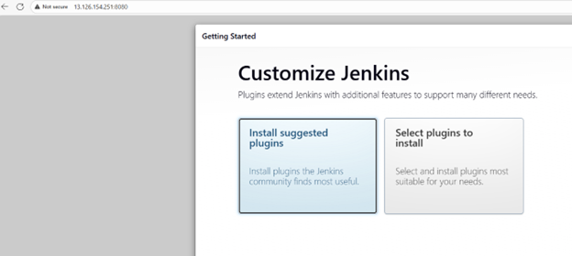
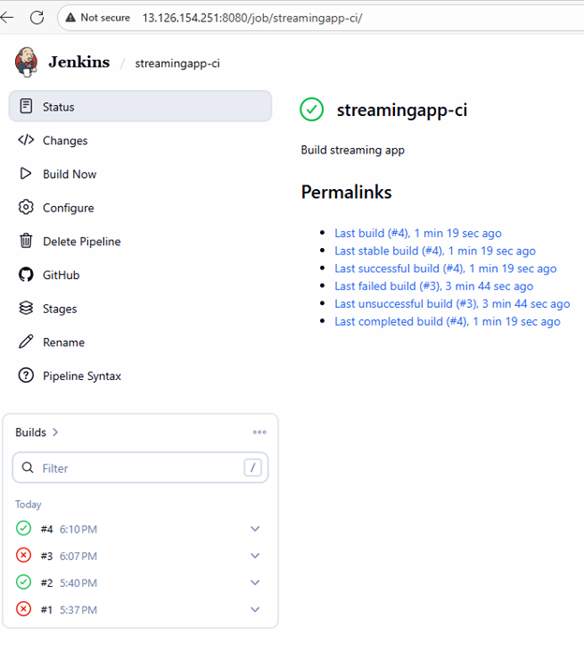
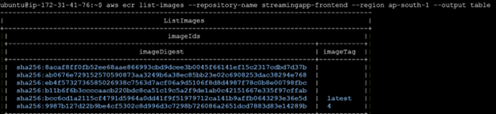
Picture 8: Jenkins build console output (build + push)
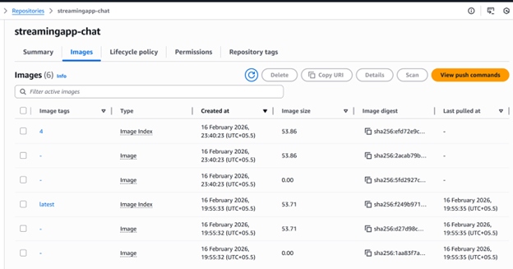
Picture 9: ECR image tags/digests after push
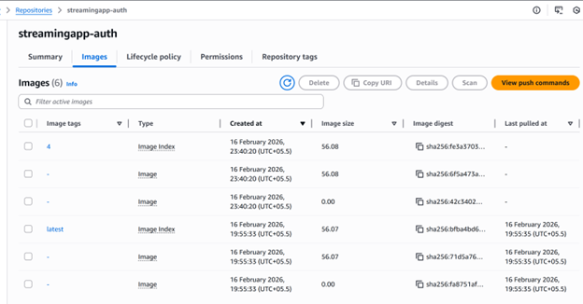
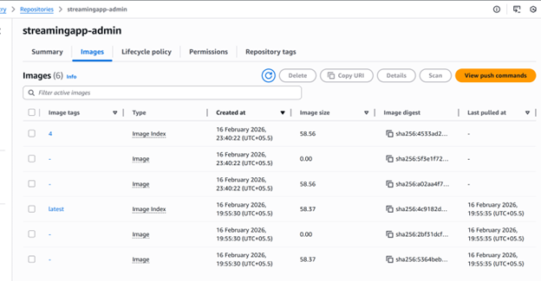
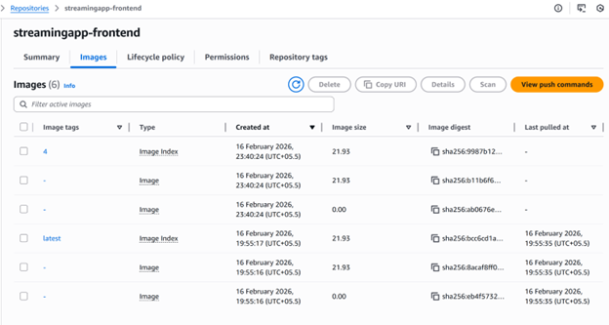
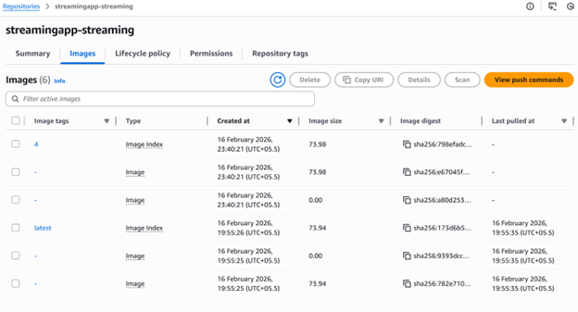

Step 5 — Kubernetes deployment (EKS + Helm)
Picture 10: EKS cluster created (eksctl/EKS console)
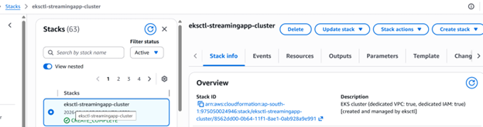
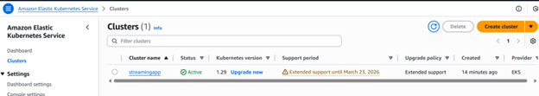

Picture 11: kubeconfig updated + nodes ready and Pods running in namespace

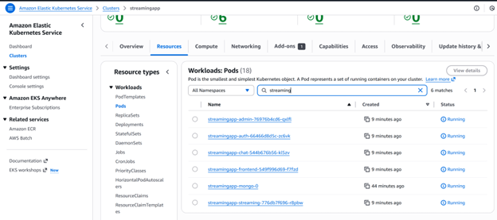
EKS + Helm Deployment Guide (StreamingApp)
This guide creates an EKS cluster using `eksctl` and deploys the StreamingApp MERN stack using Helm.
## Prerequisites
On your admin machine (your laptop or a bastion VM) install:
- AWS CLI v2
- `eksctl`
- `kubectl`
- `helm`
Make sure AWS auth works:
```bash
aws sts get-caller-identity
```

## 1) Create the EKS cluster (eksctl)

The repo includes an `eksctl` config at [eks/cluster.yaml](eks/cluster.yaml).

```bash
eksctl create cluster -f eks/cluster.yaml
```

Configure kubeconfig (usually done automatically by eksctl; run if needed):

```bash
aws eks update-kubeconfig --region ap-south-1 --name streamingapp
kubectl get nodes
```

## 2) Ensure your images are in ECR

Your Helm chart expects images already pushed to these repos:

- `streamingapp-auth`
- `streamingapp-streaming`
- `streamingapp-admin`
- `streamingapp-chat`
- `streamingapp-frontend`

(You already used these earlier with account `975050024946` in `ap-south-1`.)

## 3) Deploy with Helm

An example values file is provided at [helm/values-eks.example.yaml](helm/values-eks.example.yaml).

Create a namespace and install/upgrade:

```bash
helm upgrade --install streamingapp helm/streamingapp \
-n streamingapp --create-namespace \
-f helm/values-eks.example.yaml
```
Check resources:
```bash
kubectl get pods -n streamingapp
kubectl get svc -n streamingapp
```
By default (in [helm/streamingapp/values.yaml](helm/streamingapp/values.yaml)) the chart exposes all services as `LoadBalancer` to make it easy to use the existing frontend build approach (separate URLs per service). You can change backend services to `ClusterIP` once you move to an Ingress-based setup.
3. Rebuild/push the **frontend** image with those URLs as Docker build args, push it to ECR with a new tag.
4. Update the Helm values `services.frontend.image.tag` to that new tag and run `helm upgrade` again.

If you later switch to an Ingress that serves backend APIs under the same host as the frontend, you can rebuild the frontend once with those Ingress URLs.

## 5) Update runtime settings

## Cleanup
```bash
helm uninstall streamingapp -n streamingapp
eksctl delete cluster -f eks/cluster.yaml``

Step 6 — Monitoring and logging (CloudWatch)
# CloudWatch Observability on EKS (Metrics, Alarms, Logging)
This runbook shows a practical way to:
- collect Kubernetes metrics in **Amazon CloudWatch** (Container Insights)
- create useful **CloudWatch alarms**
- centralize **pod/application logs** in **CloudWatch Logs**
Assumptions used below:

- Region: `ap-south-1`
- Cluster: `streamingapp`

```bash
aws eks update-kubeconfig --region ap-south-1 --name streamingapp
kubectl get nodes
```
## 1) Enable EKS control-plane logging (API/Audit/Auth)

This sends **EKS control plane** logs to CloudWatch Logs.

Console:

- EKS → Clusters → `streamingapp` → **Logging** → enable:
- API server
- Audit
- Authenticator
- Controller manager
- Scheduler

CLI (example):

```bash
aws eks update-cluster-config \
--region ap-south-1 \
--name streamingapp \
--logging '{"clusterLogging":[{"types":["api","audit","authenticator","controllerManager","scheduler"],"enabled":true}]}'
```
Verify log groups in CloudWatch Logs (Console → Logs → Log groups). Look for groups named like:

- `/aws/eks/streamingapp/cluster`

## 2) Install CloudWatch metrics (Container Insights)

### Option A (recommended): CloudWatch Observability EKS add-on

If your account supports the CloudWatch Observability add-on, this is the cleanest path.

Console:

- EKS → Clusters → `streamingapp` → **Add-ons** → **Get more add-ons**
- Install **Amazon CloudWatch Observability**

CLI (if available in your environment):

```bash
aws eks create-addon \
--region ap-south-1 \
--cluster-name streamingapp \
--addon-name amazon-cloudwatch-observability
```

### Option B: Container Insights using CloudWatch Agent + Fluent Bit (Helm)

This option works broadly and gives you explicit control.

#### 2.1) Create IAM policy for metrics + logs

Create a policy (example) for the service account to write metrics and logs.

Create `cw-agent-policy.json` locally:

```json
{
"Version": "2012-10-17",
"Statement": [
{
"Effect": "Allow",
"Action": [
"cloudwatch:PutMetricData",
"logs:CreateLogGroup",
"logs:CreateLogStream",
"logs:PutLogEvents",
"logs:DescribeLogStreams",
"logs:PutRetentionPolicy"
],
"Resource": "*"
}
]
}
```

Create the policy:

```bash
aws iam create-policy \
--policy-name streamingapp-eks-cloudwatch \
--policy-document file://cw-agent-policy.json
```

Copy the created policy ARN for the next step.

#### 2.2) Create an IRSA service account

```bash
eksctl utils associate-iam-oidc-provider \
--region ap-south-1 \
--cluster streamingapp \
--approve
```

Create the service account in `amazon-cloudwatch` namespace:

```bash
eksctl create iamserviceaccount \
--region ap-south-1 \
--cluster streamingapp \
--namespace amazon-cloudwatch \
--name cloudwatch-agent \
--attach-policy-arn arn:aws:iam::<ACCOUNT_ID>:policy/streamingapp-eks-cloudwatch \
--approve
```

#### 2.3) Install the charts

Add the EKS charts repo:

```bash
helm repo add eks https://aws.github.io/eks-charts
helm repo update
```

Install the CloudWatch Agent (Container Insights):

```bash
helm upgrade --install cloudwatch-agent eks/cloudwatch-agent \
-n amazon-cloudwatch --create-namespace \
--set clusterName=streamingapp \
--set region=ap-south-1 \
--set serviceAccount.create=false \
--set serviceAccount.name=cloudwatch-agent
```

Install Fluent Bit to ship pod logs to CloudWatch Logs:

```bash
helm upgrade --install aws-for-fluent-bit eks/aws-for-fluent-bit \
-n amazon-cloudwatch \
--set cloudWatch.region=ap-south-1 \
--set cloudWatch.logGroupName=/aws/eks/streamingapp/application \
--set cloudWatch.autoCreateGroup=true \
--set cloudWatch.logStreamPrefix=from-fluent-bit- \
--set serviceAccount.create=false \
--set serviceAccount.name=cloudwatch-agent
```

Verify pods:

```bash
kubectl get pods -n amazon-cloudwatch
```

## 3) Where to see metrics

CloudWatch Console:

- CloudWatch → **Insights** → **Container Insights**
- Cluster: `streamingapp`

You should see node/pod CPU & memory, pod counts, etc.

## 4) Where to see application logs

Your Node services write logs to stdout/stderr via `console.log()` and Express logging; Kubernetes captures these automatically.

CloudWatch Logs Console:

- CloudWatch → Logs → Log groups
- `/aws/eks/streamingapp/application` (from the Fluent Bit setup above)
- plus EKS control-plane log group `/aws/eks/streamingapp/cluster`

Tip: use **Logs Insights** queries, for example:

```sql
fields @timestamp, @message
| sort @timestamp desc
| limit 50
```

## 5) Create useful alarms

Below are common alarms to set after metrics are flowing.

### 5.1) Node CPU too high (Container Insights)

Console:

- CloudWatch → Alarms → Create alarm
- Metric: `ContainerInsights` → `Node` → `node_cpu_utilization`
- Filter by cluster/node if needed
- Threshold example: > 80% for 5 minutes

### 5.2) Node memory too high

Metric: `ContainerInsights` → `Node` → `node_memory_utilization`
- Threshold example: > 80% for 5 minutes

### 5.3) Pods not ready (symptom alarm)

Metric: `ContainerInsights` → `Cluster` / `Namespace`
- Alarm when “not ready” pod count is above 0 for N minutes (exact metric names vary by setup).

### 5.4) LoadBalancer / ALB 5XX (if using AWS LB Controller)

If your app is fronted by an ALB/NLB, use ELB metrics:

- `AWS/ApplicationELB` → `HTTPCode_Target_5XX_Count`
- `AWS/NetworkELB` → `UnHealthyHostCount`

Step 9 Create SNS topics

Create topics for:
- deployment success
- deployment failure
- alarms (optional)

```bash
aws sns create-topic --name streamingapp-deploy-success
aws sns create-topic --name streamingapp-deploy-failure
```

